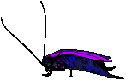Arthropod Coloring Worksheet
Arthropods (jointed appendages) are a group of invertebrate animals in the Kingdom Animalia. All arthropods have a hard exoskeleton made of chitin, a body divided into segments, and jointed appendages (mouthparts, antenna, and legs). Three main groups of the arthropods include the insects, arachnids, and crustaceans.
- What does arthropod mean?
- In what kingdom are arthropods found?
- Are they vertebrates or invertebrates? Why? (see textbook)
- List 3 characteristics of all arthropods.

- Name 3 main arthropod groups.

Insects
Insects have three body segments --- the head, thorax (middle region) and the abdomen. Often you can see segments on the abdomen of insects. Locate all the insects on the coloring sheet and label and color the head red, the thorax yellow, and the abdomen green. Insects have three sets of legs (6), which are attached to the thorax. Label and color all the insect legs blue. You will also note that each insect has one pair of sensory antenna on the head. Label and color over the antenna in gray. The mouthparts of insects have a pair of mandibles (jaws) that chew food. Unlike the teeth of other animals, mandibles open from side to side. Locate the mandibles (they are only visible on two of the insects pictured) and color and label the mandibles purple. Some, but not all insects have wings, which also attach to the thorax. Insects with wings may have one or two pairs. Color and label the wings pink. On flies the second pair of wings is modified into balancing organs called halteres. An additional body part can be seen on the grasshopper. This part, called the pronotum, is behind the head and covers and protects part of the thorax. Label and color the pronotum brown.
- Name the 3 body segments of insects.

- How many legs do insects have and which body segment are they attached to?

- How many antennae do insects have and where are they located?
- Name the insect’s jaws and explain their movement.
- Do all insects have wings? Explain your answer.
- Where are wings attached to on an insect?
- What additional body part is found on the grasshopper & where is it located?
Grasshoppers are a common type of arthropod. Read the definitions, then label and color the grasshopper anatomy diagram below:

abdomen - the segmented tail area of a grasshopper, which contains the heart, reproductive organs, and most of the digestive system (red)
antennae - like all insects, grasshoppers have 2 segmented antennae that sense touch and odors (gray)
compound eye - grasshoppers have 2 faceted eyes made up of many hexagonal lenses (light green)
head - the head is at the front end of the grasshopper's body and is the location of the brain, the two compound eyes, the mouth parts, and the points of attachment of its two antennae. (brown)
jumping legs -the long, hindmost pair of the grasshopper's six legs (dark green)
mandibles - the jaws, located near the tip of the head, by the palps; the jaws crush the food (purple)
palps - long, segmented mouth parts (under the jaws) that grasp the food (violet)
spiracles - a series of holes located along both sides of the abdomen; they are used for breathing
thorax - the middle area of the grasshopper's body - where the legs and wings are attached (tan)
walking legs - the four, short front legs that are used for walking (yellow)
wings - grasshoppers have two long wings, used for flying (light blue)

Figure 1 - External Grasshopper Anatomy
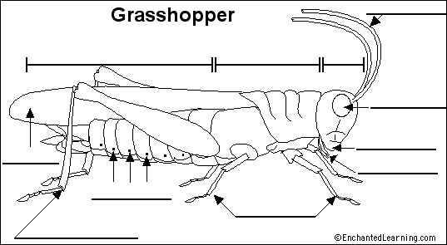

Complete these definitions:
__________13. Where legs and wings are attached
__________14. Openings for respiration
__________15. Organs for flight
__________16. Jointed mouth parts used to grasp food
__________17. Used for touch and small
__________18. Enlarged hind limbs
__________19. Last section of the insect’s body
__________20. Jaws
__________21. First two pairs of legs
Arachnids
Arachnids are a group of arthropods that include spiders, mites, scorpions, and ticks. They have two body parts --- the cephalothorax (head and thorax combined)) and the abdomen. Label and color the cephalothorax orange and the abdomen green. Arachnids have 8 legs, instead of the 6 that you find in insects. Label and color the legs blue. Notice that arachnids do not have antennae, but you can see the mandibles on the spider pictured. Label and color the mandibles purple. Tiny eyes (also called ocelli) that can only detect light and dark are located on top of the spider's cephalothorax. Most species of spiders have 8 eyes, but other species have more. Label and color the ocelli red. The pedicel, spider's waist, connects the cephalothorax and the abdomen. Label the pedicel. Pedipalps, also called palps, are two sensory feelers that look like very short legs attached to the front of the spider. Pedipalps help taste food. Label and color the pedipalps light purple. The spider’s jaws are also called chelicera. They are located below the eyes. The jaws are tipped with fangs that can inject poison. Label and color the chelicera or fangs brown. Spinnerets are where the spider's silk is released. They are located at the tip of the abdomen. Label the spinnerets.
- List members of the arachnid group.
- How many body sections do arachnids have? Name them.
- On which section are the eyes and mouthparts located?
- How many legs do arachnids have?
- Do arachnids have compound eyes like insects? Explain your answer.
- What can ocelli detect?
- What is the pedicel and what is its function?
- How many eyes do most spiders have?
- What are pedipalps and describe their appearance?
- How do spiders taste their food?
- Spider jaws are also called ________________ and have poison ___________ at the tips.
- What organ produces silk for webs?

Figure 2 – External Arachnid (Spider)
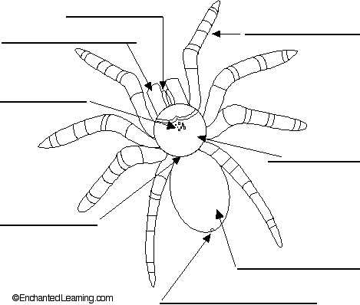
Crustaceans
Crustaceans are a group of arthropods that mainly live in the water; they include lobsters, crabs, shrimp, and crayfish. Crustaceans usually have two body segments --- the cephalothorax (orange) and the abdomen (green). The number of jointed appendages for movement & feeding on crustaceans can vary. Many of them have large claws called chelipeds used for capturing prey. Label and color the claws or chelipeds on the lobster brown. Walking legs are attached to the thorax. Label and color the walking legs blue. Notice the small, leg-like structures called swimmerets attached to the underside of the abdomen on the lobster. The lobster uses these for swimming and holding eggs and young. Male lobsters and crayfish have a pair of these modified to transfer sperm to the female. These appendages are called swimmerets. Label and color the swimmerets dark blue. Crustaceans also have sensory antenna. Label and color the antenna gray.
- Where do crustaceans live and name four?
- Crustaceans have different jointed ____________ for various jobs such as feeding and moving.
- What are the large claws on crustaceans called & what is their purpose?

- Where are walking legs attached?
- Where are swimmerets located and name three functions for these structures?
- Location?
- Function?
- Function?
- Function?
Centipede
Centipedes have long flat bodies and many legs. In fact, the word "centipede" means "hundred legs.” Centipedes actually have 4 or 2 pairs of legs on each body segment. Label and color the legs of the centipede blue and each of its body segments red. Centipedes have a pair of sensory antenna on the head. Label and color the antenna gray. Centipedes are often poisonous and feed on insects or other arthropods. They have pincers at the posterior end for capturing prey. Label and color the pincers orange.
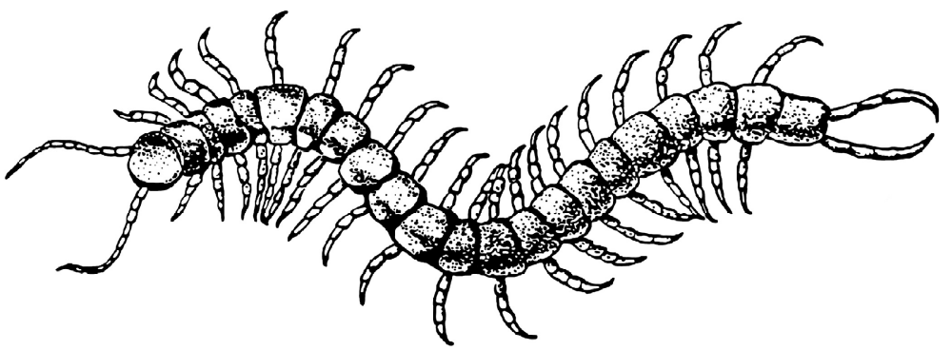
Millipedes
Millipedes are often called 1,000-legged worms or rain worms. They are wormlike in appearance with rounded body segments that each bears two pairs of legs. Label and color the body segments brown and the legs black. The head is rounded with short antennae. Label and color the head tan. Species can vary in length from less than 1 to 2 or more inches. They are light brown to black in color. Millipedes are not poisonous, but many species have glands capable of producing irritating fluids that may cause allergic reactions in some individuals. The defensive sprays of some millipedes contain hydrochloric acid that can chemically burn the skin and cause long-term skin discoloration.
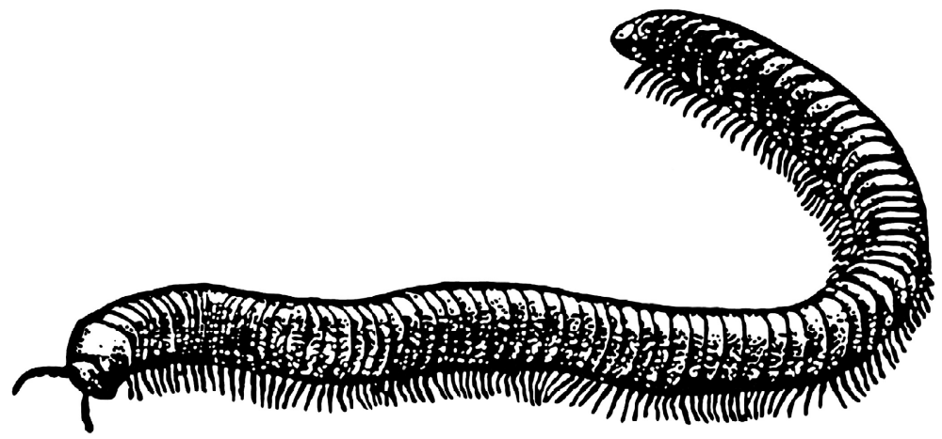
- Which is poisonous ---- millipedes or centipedes?
- Which has more legs per body segment --- millipedes or centipedes?
- Which has a flattened body --- millipedes or centipedes?
- Which produces an irritating acid --- millipedes or centipedes?
Use this table to color the arthropods on the next sheet.
Heads - YELLOW | Wings - TAN
Jumping legs – LIGHT BLUE | Antenna - BLACK
Walking legs - GREEN | Cephalothorax - PINK
Thorax - ORANGE | Chelipeds - RED
Abdomen - BROWN | Eyes – DARK BLUE
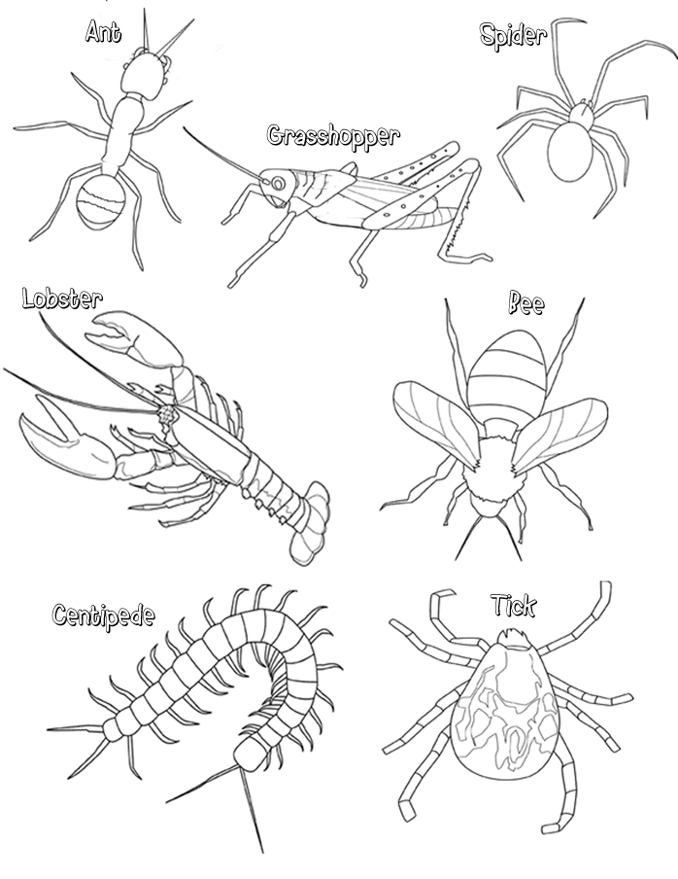
Insect Life Cycle
Many insects go through developmental stages called metamorphosis. Dramatic physical changes of the insect’s body takes place in these stages. Some insects do not go through metamorphosis and just increase in size. There are two main types of metamorphosis --- complete and incomplete. The stages in complete metamorphosis are: Egg --> Larva --> pupa ---> adult (example: butterflies). The stages in incomplete metamorphosis are: Egg --> nymph --> adult (example: crickets). The nymph looks like the adult insect but is smaller and the wings aren’t fully developed. Label the stages in each type of metamorphosis.
In incomplete metamorphosis, the nymph develops from an egg and looks like the adult, but it does NOT have fully developed wings. Color the nymph yellow and the egg red. In complete metamorphosis, a worm-like stage called the larva or caterpillar develops from the egg. This stage eats lots of vegetation storing food energy for the next stage. Color the eggs red and the caterpillar yellow. The larva or caterpillar spins a cocoon or chrysalis in which the pupa develops into an adult insect. Color the cocoon light green. The butterfly in the picture is a Monarch. Color the Monarch orange.
- What is metamorphosis?
- Name the two types.
- Name the complete metamorphosis stages.
- Name the incomplete metamorphosis stages.
- Describe nymphal insects.
- Why is the larva called the feeding stage? What is larva called?
- What is another name for the cocoon & what is its function?

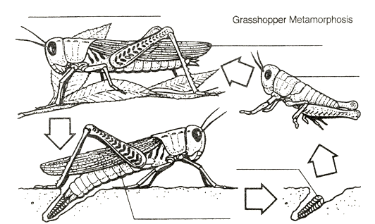

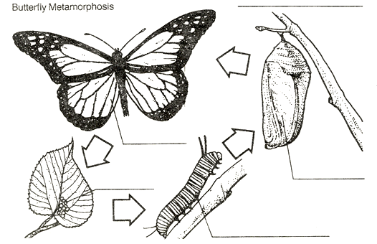
Review Questions:
1. How many body segments does an insect have? How many legs?
2. How many body segments does an arachnid have? How many legs?
3. Which groups of arthropods have antennae?
4. What part of the body can you see segmentation?
5. What are the chewing mouthparts of arthropods called?
6. To what part of the body do the wings attach?
7. The head and thorax are fused together in some arthropods to form the _______________.
8. Name the two types of metamorphosis in insects and tell how they differ.

9. What is the function of chelicera? Chelipeds?

10. Arachnids have simple eyes called _________.

11. Give three uses for swimmerets.

12. Where are the walking legs of crustaceans found?

13. What arthropod has pedipalps and what are they used for?

14. What is a chrysalis?

