Parts of Prokaryotic & Eukaryotic Cells | 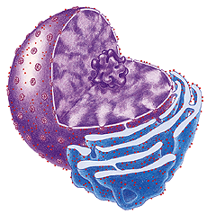
CELL THEORY

1. All living things are made of ____________.
2. Cells are the basic unit of __________ & __________ in an organism.
3. All cells come from the reproduction of ____________ cells.

CELL MEMBRANE MODEL

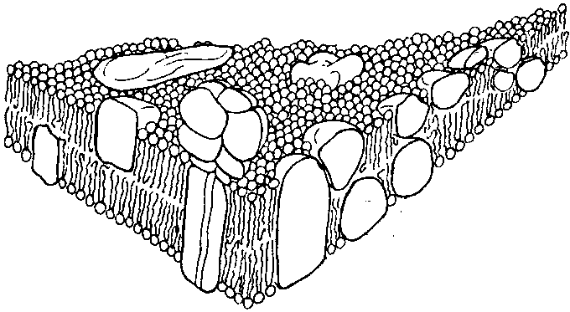 | - Phospholipids and proteins move ____________ or side to side for short distances.  - Proteins make a pattern on the surface known as the ___________ __________ model.

NUCLEUS and NUCLEOLUS

NUCLEUS is:
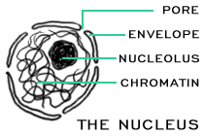
- Surrounded by ________________ MEMBRANE
called the NUCLEAR ___________________
- Serves as the __________________ CENTER OF CELL
- Nuclear _________ allow molecules in and out
- CONTAINS CELL’S GENETIC MATERIAL ( __________)
- Contains NUCLEOLUS (Dark spot) which makes _______________ (RNA)

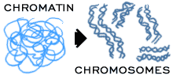
DNA is scrunched up as _________________ in DIVIDING CELLS
DNA is spread out as__________________ in NON-DIVIDING CELLS

CYTOSKELETON
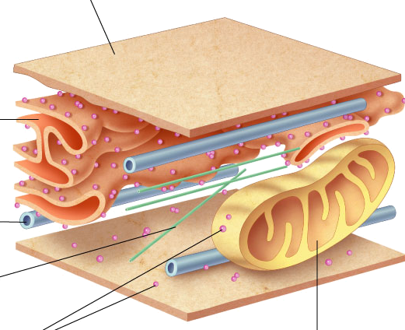
Made of PROTEINS called
_________________ and ____________________

FUNCTION: _____________________________________
____________________________________________

LYSOSOMES
Sac containing _________________________
FUNCTION:
Digests: _____________________________________________

Plays a role in __________________ “programmed cell death”
Cell suicide for the good of the ______________

VACUOLE

STORAGE SPACE FOR: _______________________________________
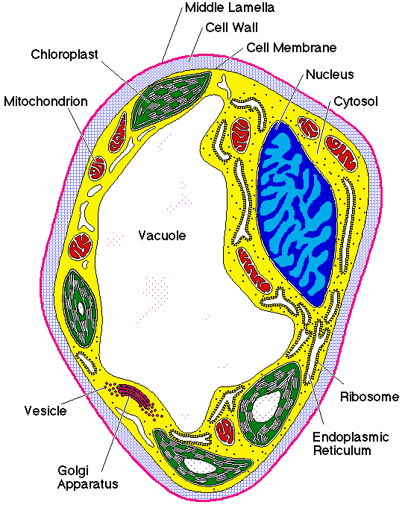
Huge in ________________cells, small in ___________ cells, NOT in ______________________ cells.

CENTRIOLES

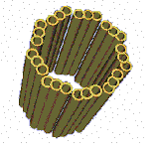
Made of PROTEINS called _________________________

Only seen in __________________ cells during cell division

Function: _____________________________________
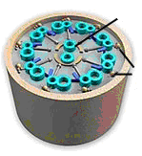
CILIA & FLAGELLA
Made of PROTEINS called _____________________
organized in a _________ arrangement
that help with ____________________________

CILIA: ________________ & _______________
FUNCTION ___________________________________

FLAGELLA: _____________ & ________________
FUNCTION ________________________________

RIBOSOMES

Can be ______________________in the cytosol or _______________ to the surface of Rough ER
MADE OF ______________ & ________
FUNCTION: _____________________________

CELL MEMBRANE or PLASMA MEMBRANE

Made mainly of _______________________ and _____________________
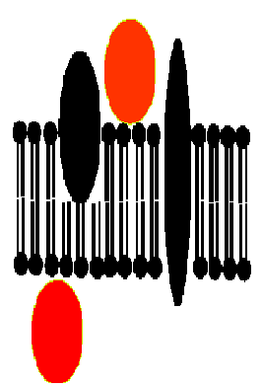
HYDROPHOBIC “tails” of phospholipids make molecules line up as a LIPID ________________ with POLAR heads facing _______ and NON-POLAR tails facing ________

Proteins attached to surface (inside or outside)= ____________________
Proteins stuck into membrane = ___________________
(can go part way in or all the way through)

Membranes are _________________ ______________________ when they allow certain molecules to pass through; but keep others out.

___________________is the “gel-like material + organelles” between nucleus and cell membrane

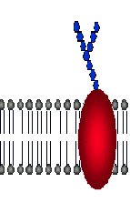
OTHER MOLECULES:
- GLYCOPROTEINS with attached _______________ tails to recognize self
- Contain the steroid ______________ to make membranes more flexible

MITOCHONDRION (plural: MITOCHONDRIA)

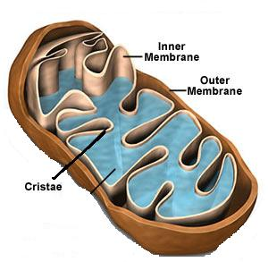
Surrounded by _____________ membrane.
Contains its own ___________.
Called the ______________________ of cell
Burns ____________ to release energy.
Stores energy released as ________.
___________ outer membrane
Folded inner membrane = ________________ (increases _______________ for more chemical reactions)

GOLGI APPARATUS (BODY)

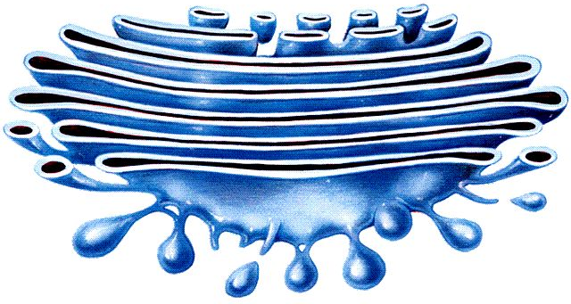
Looks like a stack of flattened _____________.
FUNCTION: Modify, sort, and package substances from ER for _________________ out of cell.

ENDOPLASMIC RETICULUM(ER)
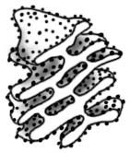
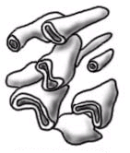
Internal network of ____________________.
Rough ER: Attached ribosomes make _____________ which are modified & exported.
ROUGH ER / SMOOTH ER
Rough ER has _____________ on its surface, while ___________ does not.
FUNCTION ROUGH ER: ______________________________________
FUNCTION SMOOTH ER: ____________________________________

CHLOROPLASTS
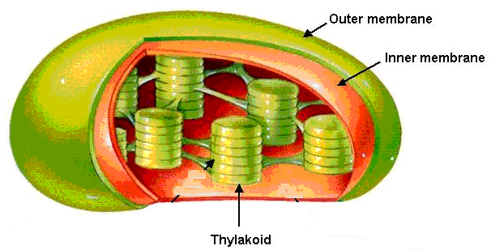
Surrounded by ____________ membrane
Has its own ________
Outer membrane __________
___________ membrane sacs called ______________ contain CHLOROPHYLL where _______________________ happens. Stacks of thylakoids called _____________. Gel like material around thylakoids called _________________.
FOUND ONLY IN _____________ CELLS

CELL WALL

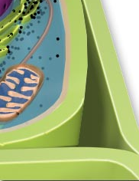
Found OUTSIDE the ________________________.
Provides __________________ & ___________________.

___________________ in the cell wall makes plant cells sturdy.

Bacteria have cell walls made of ___________________ instead of cellulose.

PROKARYOTES

________ are the most common prokaryotic cell. They do not have a ____________, but do contain a single ______________ made of DNA.

Like all cells, bacteria are surrounded by a ___________________ which contains the gel-like _______________ of the cell.
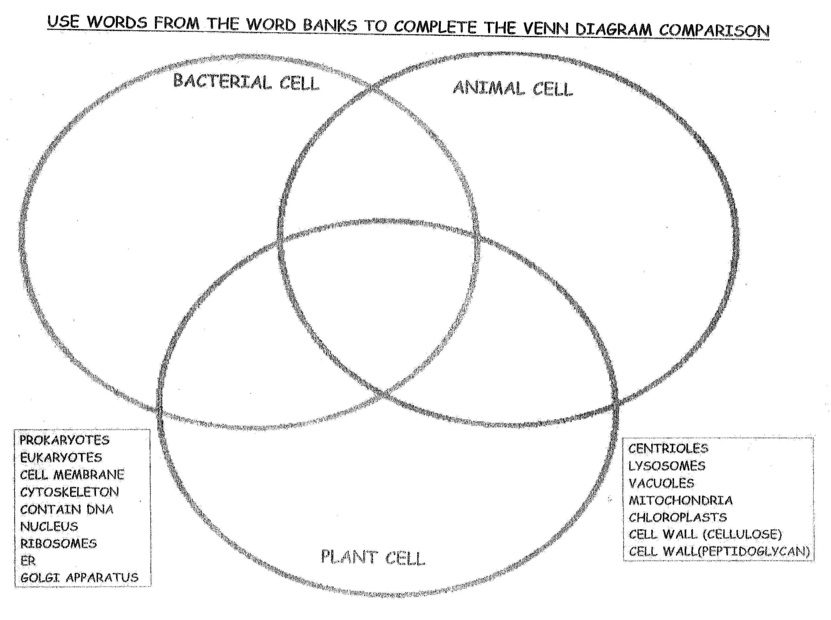

Modified from: http://brookings.k12.sd.us/biology/other_units.htm

